University of Guyana

Software Engineering: Project Plan



Group Members:

Reaad Kayum USI: 1028635

Basudev Singh USI: 1028592

Shahrukh Khan USI: 1026738

Lakeram Persaud USI: 1026752

Hueley USI: UNKNOWN

Course: CSE 2101 – Software Engineering

Institution: University of Guyana

Contents

1. Introduction
2. Purpose
3. Document Conventions
4. Intended Audience and Reading Suggestions
5. Overall Description
6. Product Perspective
7. Product Functions
8. User Classes and Characteristics
9. Design and Implementation Constraints
10. User Documentation
11. Assumptions and Dependencies
12. System Features
13. System Feature 1
14. System Feature 2
15. Other Nonfunctional Requirements
16. Performance Requirements
17. Safety Requirements
18. Security Requirements
19. Software Quality Attributes
20. Business Rules
21. Introduction
22. Purpose

The purpose of this document is to present a comprehensive description of the software MOTO INSURE. It explains the motives and features of the software along with the different limitations under which it must operate.

1. Document Conventions
2. Intended Audience and Reading Suggestions

This Software Requirements document is intended for:

* Developers – can address this document and be able to study the existing system to understand where their attempts should be projected to improve and innovate or add more features to it.
* Project Testers – can use this document to support their testing procedures given that some errors are easier to locate using the requirements document.
* End Users – can read this document to grasp and comprehend how the system works.

1. Overall Description
2. Product Perspective

This is a new system to be implemented into a Motor Insurance Company. The company is using a paper base system and has no previous digital system therefore this system will help to speed up the business processes. The software will be online and can be used at all times; it can be accessed by customers and employees. The employees can use and manipulate data also add new data while the customers can view and update their information also check new policies etc.

The customer/employee will log onto the server and will have different access levels and since the software will be data centric then there will be a database (The software system will be using the latest version of MySQL Database. This will be used in connection with the PHP My Admin to display the data in a high-level form) holding all the data, the customers will only be able to view data about themselves while the employees will be able to view all related information about their clients and they will be able to manipulate it. Memory applications should not exceed 16gb of RAM and about 5 terabytes of hard drive space to avoid overloading.

1. Product Functions

* The system needs to be able to have concurrency because many users will be accessing the database on a daily basis and if the system does not support the function then there can be multiple crashes and failures in the system which is not ideal because it can cause data loss.
* The system must be user friendly so that the employees can be able to understand how to use the system also if customers can access their information then they must be able to understand how to use the system.
* The system must be able to do back-ups on a regular basis by itself so that data is not lost in case of any physical failures.
* The system should be able to generate forms and reports for the higher-level management to use to decide on any improvements and new developments.

1. User Classes and Characteristics

There will be three they of users that will be accessing this system:

* The Customer
* The Employee
* The High-Level Management

The customer will be able to have their own user name and password to access their database so that they can view their information and make payments also to view payment statuses and to receive updates from the company also get information on the company, they will have strictly only view level access and cannot do anymore.

The employee will be able to have their own login with their own level of access with which limits what they see about the customer and what information they can add to the system. They can also generate reports and add new clients also update client information if the client cannot do that for themselves also they will be able to provide online support to customers who are using their online account.

The High-Level Management are the mangers and CEO of the company, they will be able to view everything from what the employees do to what the customers do also be able to handle security and give access to whoever request for it. They can also get reports so that they can make executive decisions for the company.

1. Design and Implementation Constraints

Design constraints

* The company does not provide a budget that covers the extensive research that is needed so the software design is one that is not as good as it is supposed to be and then the software will be built on weak information.
* The software architect leaves the designing phase half way and when a new hire comes to do the job they will extend the time that is scheduled for the project to be done therefore throws everything off track since they might want to make changes etc.

Implementation Constraints

* When the software is implemented, the current employees reject the system and prefer the old system.
* When the new software is implemented, the employees that are currently employed cannot use the system because they were not trained to use it which will cause the business to have downtime.
* The company does not have enough space in their building for the new equipment to be placed therefore postponing the implementation.

1. User Documentation
2. Assumptions and Dependencies

The employee and customer will need to have high speed internet access to use the application and its resources also the software must be able to have concurrency of users so that the system does not fail.

1. System Features
2. System Feature 1

System features.

Priorities are defined based on the needs of the users. In this document it is decided based on factors: High, Medium and low

* When a feature is listed as high in this document it’s because it is a critical feature which the users wants immediately or a feature that has impact on other features.
* Secondly When a feature is listed as medium in this document it’s because it is relatively important but not as important as the factor high.
* Lastly when a feature is listed as low in this document it’s because the feature is not required immediately or which doesn’t have any impact of basic functionality.

### Data and application hosting on google server

### Description and Priority

Application will need to be hosted on Google server Engine.  
  
Priority: high.

### Stimulus/Response Sequences

Not applicable.

### Functional Requirements

Not applicable.

### Login/create accounts

### description and Priority

Users and employees should be able to create accounts online. As for the employees they will have different access levels pertaining to their accounts. Users with accounts should be able to login.

Priority: high.

### stimulus/Response Sequences

Stimulus: User requests to create an account.

Response: System retrieves and display options to either create a user account/employee account.

Stimulus: User request to enter personal information.

Response: System provide options for user to enter information along with a sign-up button.

* 1. **Functional Requirements**

|  |  |
| --- | --- |
| Create account | The system shall allow a user to create an account with or without administrative features |

### Provides a user-friendly interface for users to choose insurance policy

### description and Priority

The system must be user friendly so that the employees/customers can be able to navigate and understand how to use the system also customers will be accessing their information so it’s mandatory that they understand how to use the system.

Priority: High

### Stimulus/Response Sequences

Stimulus: User request to view an insurance plan.

Response: System displays detail information related to the requested plan selected.

Stimulus: user request to choose an insurance plan.

Response: system will carry out payment process and other additional checks then user will be added to the database along with the payment made, vehicles and personal information’s.

### Functional Requirements

|  |  |
| --- | --- |
| Allow users to choose an insurance plan | The system shall let a User who is login the system to select and purchase an insurance plan |

### Provides concurrency access

### description and Priority

The system needs to be able to have concurrency because many users will be accessing the database on a daily basis, if the system does not provide this function there can be failures

Priority: high

### Stimulus/Response Sequences

Not applicable.

### Functional Requirements

|  |  |
| --- | --- |
| Provides concurrency access | If Two users request to access or change their insurance plan simultaneously, the system must provide this functionality. |

### Provides fulltime backups

### description and Priority

The system must be able to carry out back-ups on a regular basis by itself so that data is not lost in case of any physical failures.

Priority: high

### Stimulus/Response Sequences

Not applicable.

### Functional Requirements

|  |  |
| --- | --- |
| Provides full time backups | The system should provide full time backup |

### Generate, print, and export reports

### description and Priority

The system will need to be able to generate reports for project managers and client as well as administrators. Clients and project managers could generate and export or prints reports for their records.

Priority: medium

### Stimulus/Response Sequences

Stimulus: User requests to generate a report.

Response: System displays form containing parameters and submit button

Stimulus: Users requests to submit a report generation form.

Response: System retrieves information from database and displays report in web Brower along with options to export and print buttons.

Stimulus: User request to export report.

Response: Systems exports report to selected export option and prompts user to either save/open/cancel in dialog box.

Stimulus: User requests to print report

Response: System redirects users to pdf version of report in web browser

### Functional Requirements

|  |  |
| --- | --- |
| Report Submit | The system shall allow the user to fill out a form to be submitted through the website. |
| Report Submit Incomplete | The system shall check to see if all required information is present, and prompt the user to fill out missing data and resubmit. |
| Report Submit Recall | The system shall recall any previously saved data and fill in the application automatically |
| Report Export | The system shall recall data from database and format in file according to export preference. |
| Report Print | The system shall recall data from database, generate a PDF of formatted data and display PDF. |

Use case specification

The various user classes identified the following use cases and primary actors for the Motor Insurance Company System:

|  |  |
| --- | --- |
| Primary Actor | Use Cases |
| Database Manager | 1. Add user 2. Remove user 3. Modify user 4. View user 5. Verify user |
| Employee,  Claims clerk | 1. Provide information on the various insurance plans 2. Display insurance plans to user 3. Update insurance plan 4. Help users apply for a plan 5. Generate reports |
| The High-Level Management,  CEO and managers | 1. Access reports 2. Make major corporate decisions 3. handle security and give access to whoever request for it. |

Use case diagram for the motor insurance company system.

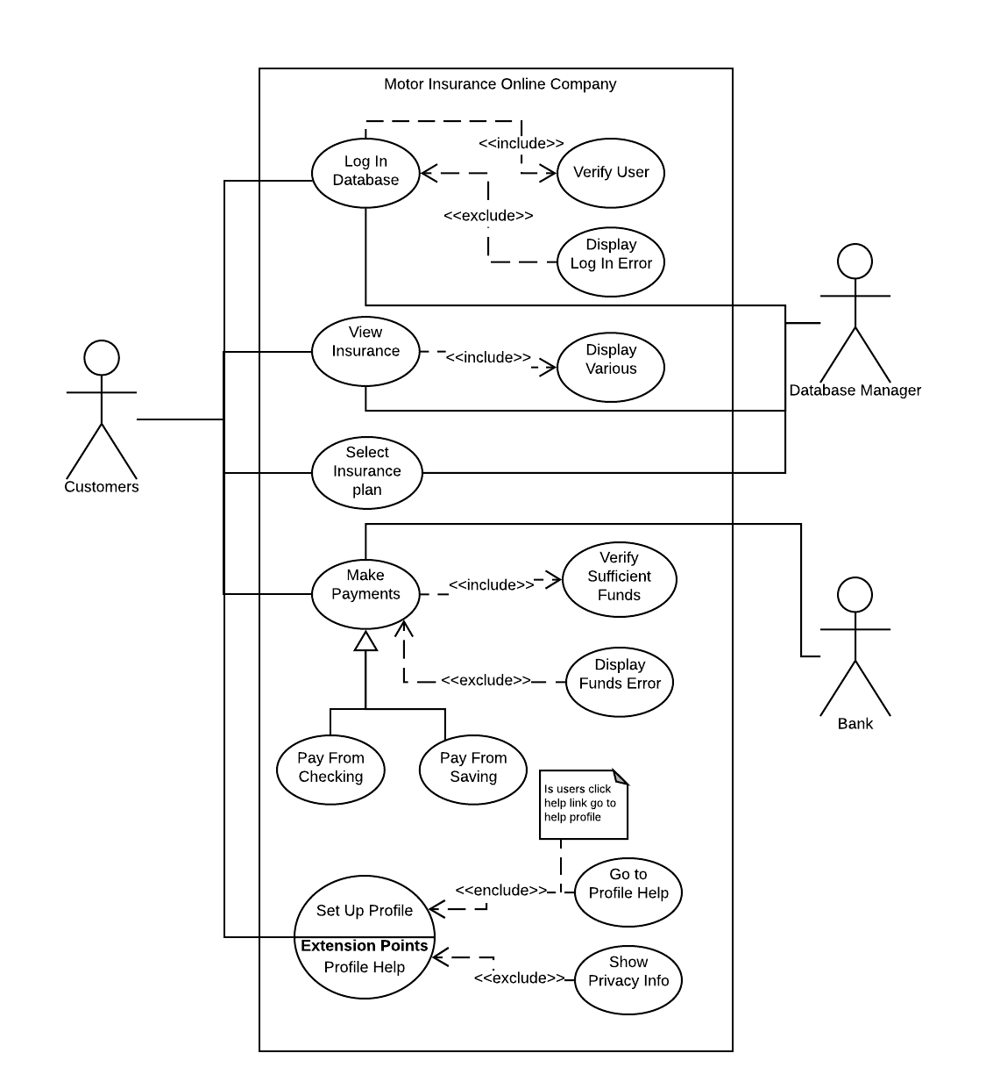

1. System Feature 2
2. Other Nonfunctional Requirements
3. Performance

The system has a 4.8 gigahertz or more processing power with 16 gigabytes of RAM. With those specifications the system is interactive and delays are narrowed to an extreme extent allowing users to quickly, efficiently and with no wasted effort, access and retrieve information promptly.

1. Safety

If there is any great damage to an extensive portion of the database due to some catastrophic event or failure, the recovery method within the system will restore a past copy of the database that was backed up to the archival storage location and redoing all the workings that were done by users up to the time of failure.

1. Security
2. Software Quality Attributes
3. Business Rules